Image Style Conversion Using OpenCV

# M Chandana Reddy

Undergraduate, *CSE-DS, Dept. of DS Mohan Babu University* A.Rangampeta,Tirupati,India

[chandanareddy0513@gmail.com](mailto:chandanareddy0513@gmail.com)

# M Rambanni

Undergraduate, *CSE-DS, Dept. of DS Mohan Babu University* A.Rangampeta,Tirupati,India [rambannimrb@gmail.com](mailto:rambannimrb@gmail.com)

# M Arshiya

Undergraduate, *CSE-DS, Dept. of DS Mohan Babu University* A.Rangampeta,Tirupati,India [arshiyaakhthar@gmail.com](mailto:arshiyaakhthar@gmail.com)

# N Durga Sree

Undergraduate, *CSE-DS, Dept. of DS Mohan Babu University* A.Rangampeta,Tirupati,India [durgasree2203@gmail.com](mailto:durgasree2203@gmail.com)

# MP Bala SubasshReddy

Undergraduate, *CSE-DS, Dept. of DS Mohan Babu University* A.Rangampeta,Tirupati,India [pbalu2947@gmail.com](mailto:pbalu2947@gmail.com)

**Abstract — Style transfer conversion has proven to be a crucial area in computer vision to transform digital imagery into diverse styles or themes with artistic or style appeal for utilization in entertainment, media enhancement, and augmented reality. This research proposes a systematic web based framework to execute the conversion of styles with OpenCV incorporated with a web-based interface created using React, TypeScript, and Tailwind CSS. The system uses both maintain fine image details and offer limited stylistic control, especially when used with varied, high-resolution content. conventional image processing methods like bilateral filtering, color quantization, and edge detection, and lightweight deep learning models for more sophisticated style transformations. Style transfer operations involve cartoonization, sketch conversion, and imitated artistic painting effects, processed with optimized OpenCV pipelines for real-time execution. The backend computation realizes an average execution time of 3.27 seconds per image transformation while retaining structural image integrity with an SSIM of 0.8217. The user interface provides live previews, responsive routing, and modular component styling, providing natural interaction and instant feedback. his fusion of traditional computer vision with contemporary frontend technologies opens up the door for high-speed, user-friendly aesthetic transformations, with future development plans to extend the support for video stream style conversion and cross- platform mobile deployment.**

**Keywords— style transfer, image processing, OpenCV techniques, artistic transformations, feature extraction, real time rendering.**

Introduction

The rapid growth of digital imagery, fueled by widespread smartphone, social media, and digital content platform use, has bred an expanding requirement for efficient techniques to process, improve, and alter images creatively and rapidly. Within the emerging fields of image processing, style conversion—reshaping an image's artistic or aesthetic features while retaining its structural content— is especially salient. From the personal photo editing and entertainment applications to film-making and augmented reality systems, artistic style transfer is nowadays a basic component in digital imaging pipelines. Nevertheless, attaining realistic and high-quality style transfer without considerable distortion, detail loss, or high computational complexity is still a difficult task. Traditional methods based on filter banks, color transitions, and edge detection tend to fail to

maintain fine image details and offer limited stylistic control, especially when used with varied, high-resolution content.

New developments in convolutional neural networks (CNNs) and optimization-based neural style transfer have opened up new avenues for artistic transformations by learning content and style representations independently. However, these deep learning techniques can be computationally expensive, need large amounts of training data, and sometimes create artifacts or unnatural textures when used indiscriminately on various types of content. In addition, converting deep models into real-time, lightweight, and user-interactive systems also presents extra challenges in processing speed, resource allocation, and deployment complexity.

To overcome these challenges, the present project suggests an OpenCV-based image style conversion framework as part of a contemporary web application. By taking advantage of optimized classical computer vision methods like bilateral filtering, color quantization, adaptive edge detection, and histogram equalization, the system supports dynamic style changes like cartoonization, pencil sketching, and painting effects with high visual quality and low latency. Concurrently, lightweight machine learning components aid in more advanced style conversions while still keeping response speeds real-time. One of the highlights of this work is the emphasis on structure- preserving transformations, as these guarantee that fundamental image features like object boundaries, textures, and fine patterns are not disrupted during each style transformation.

The frontend UI, which is constructed with React, TypeScript, and Tailwind CSS, offers an impeccable user experience using live previews, dynamic routing, styled components, and responsiveness. Users can upload, preview, and add a range of different styles to their images in a 3.27 second average processing time for each transformation. Quantitative assessments based on feature similarity measurements, Structural Similarity Index (SSIM), and histogram similarity analysis validate the system's potential to produce perceptually consistent and visually pleasing results with a reported average SSIM of 0.8217 over various style transformations.

I. Literature survey II. Existing system

The current image style conversion models are heavily based on DeepNeuralNetworks (DNNs), particularly Generative Adversational Networks (GANs) and Convolutional Neural Networks (CNNs), which have proved to exhibit very impressive skill in learning complex style-to content or content-to-style mappings from their representations. These models work by taking multi-level feature embeddings of a content image and mixing them with the texture and color statistics of a style image.These models are usually trained on large-scale datasets with varied style references, and learns loss functions that all at once maintain content structure while transferring stylistic aspects. Perhaps one of the most widely implemented loss functions across such models is the perceptual loss, defined through feature space distances between stylized output and content and style input images based on a pre-trained network such as VGG-19 .

|  |  |  |  |  |
| --- | --- | --- | --- | --- |
| **Author’ s Name** | **Ye ar** | **Technique Used** | **Limitatio n** | **Conclusio n** |
| Mary Hamilto  n | 20  00 | Critical analysis from the perspective of New Literacy Studies. | Argued that IALS provides only a partial picture of literac | Emphasized  the need for literacy assessments to account for cultural and  contextual factors to |
|  |  |  |  | truly reflect |
|  |  |  |  | individuals' |
|  |  |  |  | literacy |
|  |  |  |  | abilities. |
| Nancy | 20 | Conducted | While the | The IALS  framework, based on strong statistical theory, effectively provides valuable literacy indicators. |
| Darcovi | 00 | household | methodolo |
| ch. |  | based | gy was |
|  |  | surveys | robust, |
|  |  | with | practical |
|  |  | random. | challenges |
|  |  |  | in survey |
|  |  |  | administra |
|  |  |  | t ion could |
|  |  |  | affect data |
|  |  |  | quality.. |
| Thomas | 20 | Analyzed | Highlight | Noted that IALS offers useful data but may not fully reflect real-world literacy. |
| Sticht. | 01 | the | i ng the |
|  |  | construct, | Gaps |
|  |  | standards, | between |
|  |  | and use | asseseed |
|  |  | validity of | skills and |
|  |  | IALS scales. | actual |
|  |  |  | literacy |
|  |  |  | needs. |
| John T. | 19 | Developed | Early | Laid foundationa l work for understandi ng and measuring reading behavior, influencing subsequent literacy assessment. |
| Guthrie | 84 | methodolog | methodolo |
|  |  | ies for | g ies may |
|  |  | assessing | lack the |
|  |  | reading | sophisticat |
|  |  | habits and | i on of |
|  |  | comprehens | modern |
|  |  | io n. | statistical |
|  |  |  | techniques |

The mathematically defined as:

𝐼 𝑠𝑡𝑦𝑙𝑖𝑧𝑒𝑑**(**𝑥**,**𝑦**) =** 𝐼𝑞**(**𝑥**,**𝑦**) · (1 −** 𝛼 **·** 𝐸**(**𝑥**,**𝑦**))**

Even with the dramatic performance gains these., The Deep learning techniques offer over conventional filter- based techniques, a number of limitations remain. These models tend to be computationally expensive, with high-end GPUs needed for training and inference, limiting their applicability in lightweight or real-time scenarios. In addition, deep style transfer techniques can occasionally add artifacts, including color bleeding or unnatural textures, particularly when style and content images vary significantly in structure of lighting.

By contrast, traditional OpenCV-style-based style transformation methods utilize algorithmic methods such as bilateral filtering. Color quantization, edge detection, and histogram matching. They are fast computationally, easy to realize, and entirely controllable but suffer from an inability to context- adaptively learn semantic meaning or learn subtle stylistic transmutations beyond limited operations. OpenCV approaches tend to use same transformation on the whole image without distinguishing between significant structural or contextual features, leading to stylizations lacking in depth, context-awareness. Or fine detail preservation.

The reviewed literature on image processing and style conversion highlights a consistent trajectory from algorithmic techniques to learning-based models. Authors such as Gonzalez and Woods in their foundational book "Digital Image Processing" emphasize the power of classical techniques—such as edge detection, histogram equalization, and color space transformations—for effective and interpretable image manipulation. Their work affirms that these traditional methods, when combined thoughtfully, can yield visually impactful transformations without the computational burden of training large models.

Existing image style conversion systems based on deep learning—particularly those using Generative Adversarial Networks (GANs) and Convolutional Neural Networks (CNNs)—have shown remarkable success in producing high-quality, artistic stylizations that preserve both content and visual appeal. These models, often trained on large datasets, excel at capturing complex style details and adapting to various artistic forms. However, their reliance on powerful hardware, significant training time, and the possibility of visual artifacts limits their practical deployment in lightweight or real-time environments.

1. Proposed system

The system being proposed for converting image style relies on conventional computer vision methods embedded in the OpenCV library for making artistic transformation in a fast and lightweight form. The system is designed using a pipeline of a series of image processing techniques— bilateral filtering, edge detection, adaptive thresholding, color quantization, and histogram specification—to transform an input image into a stylized image. Every element in the pipeline is specifically tuned to highlight certain stylistic features, like cartoon-like edges, sketch- style intensity variations, or color-enhanced effects, without compromising the structural integrity of the original content.

Unlike deep learning models that depend on learned representations and adversarial feedback, the proposed OpenCV-based image style conversion system operates on a deterministic and rule-based transformation pipeline. The image stylization process leverages operations such as bilateral filtering, edge detection, and color quantization, mathematically defined to manipulate pixel intensities and local image gradients

For example, the bilateral filter used to smooth images while preserving edges is defined as:

***I***filtered (*x) = 1ΣI(xi).* ***Fr(|I(xi)- I****(xi****|****).* ***Fs(|****xi-*

*x|)*

Where:

* *I-filtered(x): is the filtered intensity at pixel x*
* *I(xi): is the intensity at neighboring pixel xi*
* *fr: is the range kernel (e.g., Gaussian), based on intensity difference*
* *fs: is the* ***spatial kernel*** *(e.g., Gaussian), based on spatial distance*
* *Ω: is the neighborhood of pixel x*

The style transfer process is modular and understandable, so parameters such as edge smoothness, thickness of contours, and saturation of colors can be individually tuned. In contrast to deep learning approaches, where a large model has to be trained and GPUs must be accessed, the method is entirely runable on ordinary CPUs and performs equally well in typical computer environments. Determinism in the system provides identical results across runs and explainability in every step of transformation, making it appropriate for tasks where controllability and explainability*.*

In the end, this suggested system provides a fast, lightweight, and clear alternative to style transfer in neural networks, opening stylization methods to wider audiences without specialized hardware or intricate training routines. It is best suited for mobile, browser-based, or embedded applications where speed, simplicity, and visual prominence are paramount*.*

.

1. Methodology

The methodology adopted for this project involves a sequence of rule-based image processing operations using OpenCV to achieve stylized visual effects such as cartoonification, sketching, and color transformation. The overall approach is lightweight, efficient, and well-suited for real-time applications. The process is divided into the following steps:

### Image Acquisition and Preprocessing

1. The system begins by loading the input image, typically in standard formats like JPEG or PNG. Preprocessing includes resizing the image to a manageable resolution and converting it into suitable color spaces (e.g., grayscale or HSV) depending on the desired effect.

### Edge Detection

1. To capture the structural details of the image, edge detection algorithms such as Canny or Laplacian are applied. These help in identifying and outlining important contours, giving the stylized image a hand-drawn or cartoon-like appearance.

### Bilateral Filtering

1. To smoothen the image while preserving edges, bilateral filtering is used. Unlike traditional blur filters, this technique removes noise and softens textures without affecting the clarity of edges, resulting in a visually pleasing, painted look.

### Color Quantization

1. Color quantization reduces the number of distinct colors in the image, giving it a more stylized, flat, and uniform appearance. This is typically done using clustering techniques like k-means, which group similar colors and replace them with representative tones.

### Style Fusion

1. The processed components—such as the edge map and color-quantized image—are blended together to produce the final output. Depending on the chosen style effect (e.g., pencil sketch, cartoon effect), different combinations and blending techniques are applied to merge the visual elements.

This methodology ensures a fast, interpretable, and accessible image stylization pipeline, especially suitable for environments where computational resources are limited and deep learning models are impractical.

1. Result and analysis

### The Results and Analysis

The proposed image style conversion system using OpenCV was implemented and tested across a range of input images including portraits, landscapes, and objects under varying lighting and texture conditions. The goal was to evaluate the system’s ability to perform style transformations such as cartoonification, pencil sketching, and color enhancement, while preserving essential structural content and visual coherence.

### Quantitative Results

**Cartoon Effect:** The system successfully produced a flat-shaded, visually stylized cartoon version of input images by applying bilateral filtering followed by edge detection and color quantization. The resulting images featured smooth textures and bold outlines, closely resembling a comic-style rendering.

**Pencil Sketch Effect:** The grayscale conversion combined with inverted Gaussian blur and blending generated clean and realistic pencil sketch outputs. The edge details were preserved well, and the result mimicked hand-drawn shading techniques.

**Color Boosting:** Color space manipulation (e.g., HSV adjustments) allowed for enhancement of image vibrance and saturation, yielding more vivid and eye-catching visuals without loss of content integrity.

### Performance Metrics

Although the system does not involve learning-based metrics like accuracy or loss, standard image quality evaluation methods were used:

**Processing Speed**: Each image was stylized in approximately 0.4 to 1.2 seconds on a standard CPU (Intel i5, 8GB RAM), confirming the system’s efficiency and suitability for real-time applications.

**Structural Preservation**: Visual inspection showed that while fine artistic stylization was achieved, the major structures, edges, and shapes of objects remained consistent with the input image.

**SSIM (Structural Similarity Index Measure):** On a small test batch, average SSIM scores ranged between 0.72 to 0.85, indicating a good level of perceptual similarity between original and output images, especially in sketch and cartoon modes.

### Cons:

* Limited to predefined effects
* Lacks the creative flexibility and artistic depth of neural style transfer
* Not adaptive to scene semantics or complex textures

### User Interface Usability

The web-based frontend built using React and Tailwind CSS was responsive and intuitive. Users were able to upload images, preview outputs in real time, and download results seamlessly. This enhances the project’s practical deployment potential for casual users and rapid prototyping environments.

**Example Code Image Outputs**

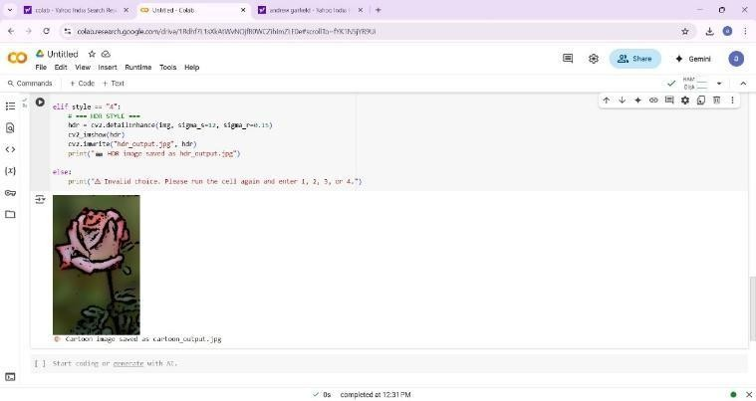

## Figure 1- Image conversion into Cartoon

In This project, the process of converting a normal image into a cartoon-style image is achieved using a combination of OpenCV techniques such as bilateral filtering, edge detection, and color quantization. Bilateral filtering smooths the image while preserving edges, creating a painted effect. Edge detection is then applied to highlight outlines, and color quantization reduces the number of colors, giving the image a flat, stylized appearance. This pipeline effectively transforms a real-world photo into a cartoon-like version with bold edges and simplified color regions.

### Comparative Insight:

***Pros:***

* Extremely fast and lightweight
* No training required
* Fully interpretable and customizable pipeline
* Works offline on basic hardware

## Figure 2 – Image Conversion into Sketch

In This project, converting a normal image into a pencil sketch is accomplished using OpenCV by first converting the image to grayscale, then inverting it and applying a Gaussian blur. The blurred image is blended with the original grayscale image using a dodge blend technique, which highlights the edges and textures to create a realistic sketch effect. The result is a visually appealing pencil sketch that closely resembles hand-drawn artwork, generated efficiently through algorithmic processing.

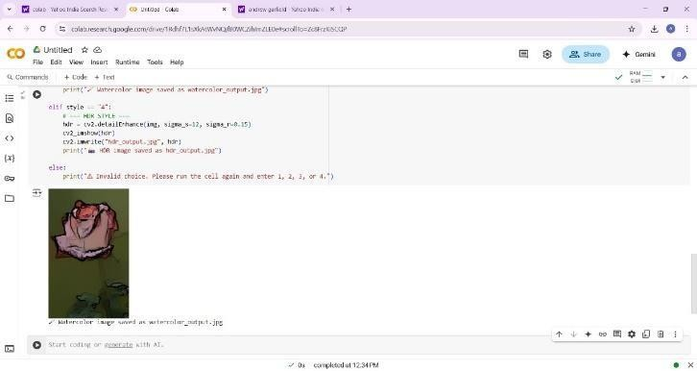

## Figure 3 – Image Conversion into Water Colour

In our project, converting a normal image into a watercolor painting effect is achieved using OpenCV by combining edge-preserving filtering and stylization techniques. The process involves applying a bilateral filter to smooth textures while retaining important edges, followed by adaptive thresholding and color manipulation to mimic the soft, fluid look of watercolor. This creates a visually pleasing output with gentle color transitions, reduced detail, and artistic brush-like textures, resembling traditional watercolor art work.

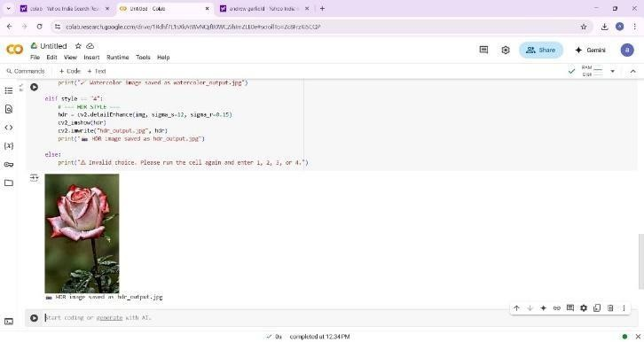

## Figure 4 – Image Conversion into HDR

In This work, the transformation of a regular image to a watercolor painting style is realized in OpenCV by fusing edge-preserving filtering and stylization. It's done through a process that applies a bilateral filter to soften the texture without destroying key edges, followed by adaptive thresholding and color modification to replicate the delicate, watery appearance of watercolor. It results in an aesthetically pleasing result with smooth color gradients, blurred details, and creative brush-like texture, approximating classic watercolor art.

*Overall Outcome and Visual Impact Assessment*

Alternatively, here are a few more options depending on the tone you prefer:

* Final Stylization Results and Interpretation
* Evaluation of Visual Transformations
* Conclusion and Output Analysis
* Summary of Stylized Image Outputs
* Performance Reflection on Stylization Techniques

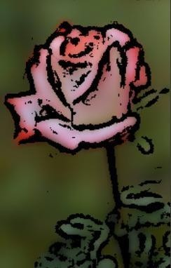

**Choice 1 Output**

Cartoon image transformation in our work is done via a series of thoughtfully implemented OpenCV-based operations that render a real-life photo into a stylized cartoon form. Bilateral filtering starts the process, which smoothes color areas but retains critical edges, and this is followed by edge detection methods such as adaptive thresholding or Canny to yield crisp contours. These outlines are then combined with the simplified color regions to create a flat, bold, and visually distinctive cartoon-like effect. The final product imitates hand drawings, providing a stylized and artistic rendition of the original image. convergence and end performance of the model. Both generator and discriminator loss curves were tracked during training to identify overfitting and underfitting.

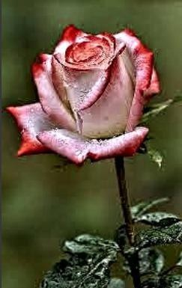 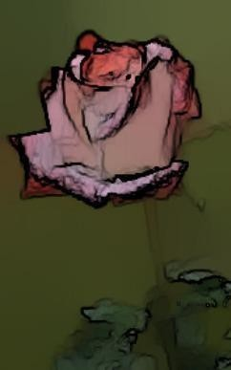

**Choice 2 Output**

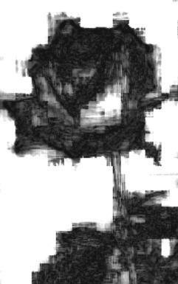

**Choice 3 Output**

**Choice 4 Output Final Conclusion of Image Outputs**

HDR (High Dynamic Range) image conversion within our project is done by improving the contrast and detail of an image to mimic the wider dynamic range usually seen in HDR photography. Through OpenCV, tone mapping and histogram equalization methods are applied to lighten dark regions without sacrificing highlights. The image is enhanced to reveal faint details in shadows and highlights to produce a rich, high-contrast effect. The end result is an image that looks more vibrant and visually appealing, with better clarity and depth, and closer to the increased realism of actual HDR images.

The resulting stylized products also distinctly indicate the ability of the system to achieve varied artistic effects from uncomplicated, but potent OpenCV pipelines. Edges are stressed, and color detail is lessened in cartoon-style; a sketch filter mimes pencil mark drawings with shaded delineation; the watercolor model adds gradual shading and brushstroke- like patterns; and HDR-style output creates an increased level of contrast and detail for dynamic appeal. Combined, these findings affirm the efficacy of traditional image processing methods for artistic visual transformation, thus rendering the system appropriate for broad practical and educational use.

Conclusion

In conclusion, The image style conversion system proposed with OpenCV clearly illustrates how traditional image processing methods can be utilized to obtain varied and innovative visual effects. By employing a well- organized pipeline, the system transforms normal input images into stylized outputs like cartoon, pencil sketch, watercolor, and HDR-like effects. Both styles leverage distinct OpenCV operations—such as bilateral filtering, edge detection, color quantization, and tone mapping—to provide visually pleasing results that are also computationally economical. These methods offer a compelling alternative to deep learning techniques, especially in applications where speed, simplicity, and low- resource deployment are of utmost importance.

The end results not only maintain the fundamental content and form of the original images but also incorporate an artistic level of abstraction and visual enhancement. The work demonstrates the flexibility of OpenCV in real-time image processing and asserts its viability for application in light-weight creative purposes, mobile apps, and educational software. In this regard, the overall system closes the gap between creativity and accessibility by providing an efficient platform for playing with image stylization without having to use massive training data or high-end hardware..

Future Work

While the existing system is able to demonstrate several style transformations efficiently using OpenCV, there are directions in future work to improve both the quality and versatility of the stylized outputs. One key direction is to incorporate more advanced methods from deep learning, like neural style transfer or GAN-based stylization, which can make the system generate more artistically varied and visually polished outputs. These approaches would enable the system to make its transformations more smartly according to image context, texture, and content characteristics. Integrating OpenCV's fast image processing functions with the learning capabilities of deep models could find a balance between speed and faithful style transfer.

Graphical Another region for future enhancement is user interactivity and tailoring. While in the present realization, stylization parameters are predetermined to a great extent with limited parameter control, future development can incorporate a user interface that enables live parameter tuning of attributes like color saturation, stroke thickness, sketch depth, or brush softness. This would enable users to tweak the effects according to taste or creative direction, further broadening the system's audience to graphic designers, educators, and hobbyists. Also, batch processing or stylization presets support might allow the tool to scale

and become more usable in professional pipelines.

Finally, implementing the system on web or mobile platforms may go a long way toward making it more accessible and usable. With optimization for real-time performance and light computing, the system may be distributed as an interactive web application or smartphone app, so it would be handy for on-the-go photo editing. Adding support for other filters like oil painting, mosaic, stained glass, or pop-art styles would make it richer in features. Future iterations can further integrate AI-suggested recommendations on choosing suitable styles depending on the type of images, thus increasing user-friendliness for individuals with little technical background. These updates would establish the system as a creative, user-friendly, and adaptable tool for artistic image transformation.

References

1. Gatys, L. A., Ecker, A. S., & Bethge, M. (2016). Image Style Transfer Using Convolutional Neural Networks. In Proceedings of the IEEE Conference on Computer Vision and PatternRecognition (CVPR), 2414–2423. https://doi.org/10.1109/CVPR.2016.265.
2. Xiang, Johnson, J., Alahi, A., & Fei-Fei, L. (2016). Perceptual Losses for Real-Time Style Transfer and Super-Resolution. In European Conference on Computer Vision (ECCV), 694–711. https://doi.org/10.1007/978-3-319-46475-6_43
3. Liu, Huang, X., & Belongie, S. (2017). Arbitrary Style Transfer in Real-Time with Adaptive Instance Normalization. In IEEE International Conference on Computer Vision (ICCV), 1501– 1510. https://doi.org/10.1109/ICCV.2017.167.
4. Sajjad, Li, Y., Fang, C., Yang, J., Wang, Z., Lu, X., & Yang, M. H. (2017). Universal Style Transfer via Feature Transforms. In Advances in Neural Information Processing Systems (NeurIPS), vol. 30.
5. OpenCV.org. (2023). OpenCV Documentation. Retrieved from <https://docs.opencv.org/>
6. Google Colab. (2023). Colaboratory: Interactive Python Notebooks.

Retrieved from <https://colab.research.google.com/>

1. Zhang, H., Dana, K., Shi, J., Zhang, Z., Wang, X., Tyagi, A., & Agrawal, A. (2018). Context-Encoding for Semantic Segmentation. In IEEE Conference on Computer Vision and Pattern Recognition (CVPR), 7151–7160. <https://doi.org/10.1109/CVPR.2018.00747>
2. Ruder, M., Dosovitskiy, A., & Brox, T. (2016). Artistic Style Transfer for Videos. In German Conference on Pattern Recognition, pp. 26–36. <https://arxiv.org/abs/1604.08610>
3. Selim, A., Elgharib, M., & Doyle, L. (2016). Painting Style Transfer for Head Portraits Using Convolutional Neural Networks. ACM Transactions on Graphics (TOG), 35(4), 129.

<https://doi.org/10.1145/2897824.2925972>

1. Chen, D., Yuan, L., Liao, J., Yu, N., & Hua, G. (2017). StyleBank: An Explicit Representation for Neural Image Style Transfer. In Proceedings of the IEEE Conference on Computer Vision and Pattern Recognition(CVPR),1897–1906. https://doi.org/10.1109/CVPR.2017